Name : Mriganka Patra

Emp ID : 2415820

Email : mriganka.patra@cognizant.com

Day 7

Assignment 1

Task1: Identify a key business object (eg: Leads, Opportunities or Project)

A key business object is **Opportunities**.

In a sales context, an **Opportunity** represents a potential revenue-generating deal with a customer or prospect. It tracks the progress of a sale from the initial contact through various stages—such as qualification, proposal, and negotiation—to either a closed-won or a closed-lost outcome. Opportunities help sales teams manage their pipeline, forecast revenue, and prioritize their efforts effectively.

Task 2: Create at least 2 custom reports using filters and groupings:

* Report1: Opportunities by Stage
* Report2: Projects by Status and Budget Range

1. Open App Launcher and Search for Reports

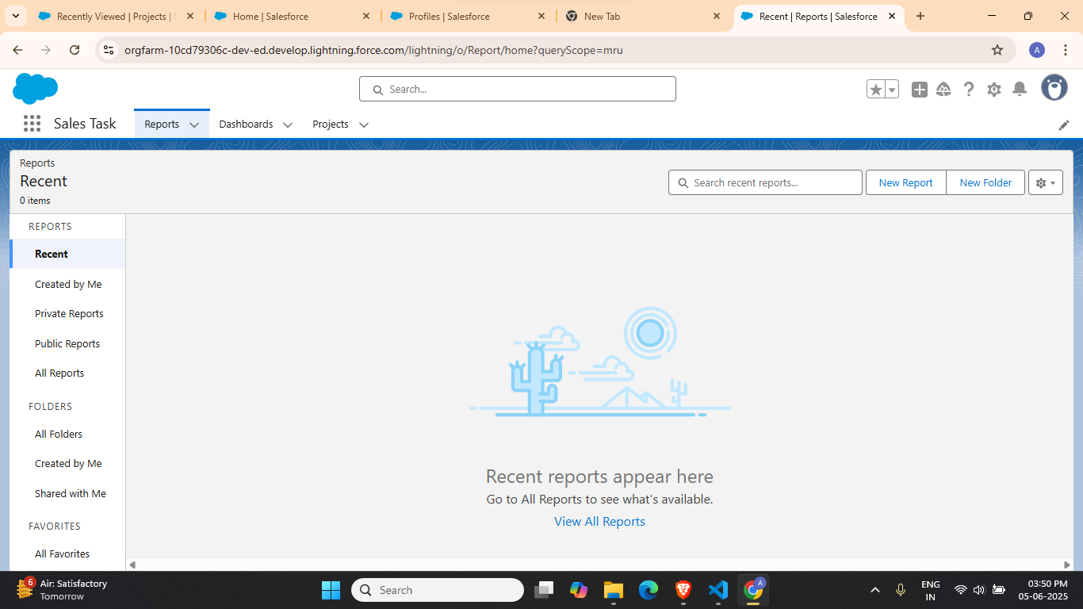

1. Create New Report on Opportunities

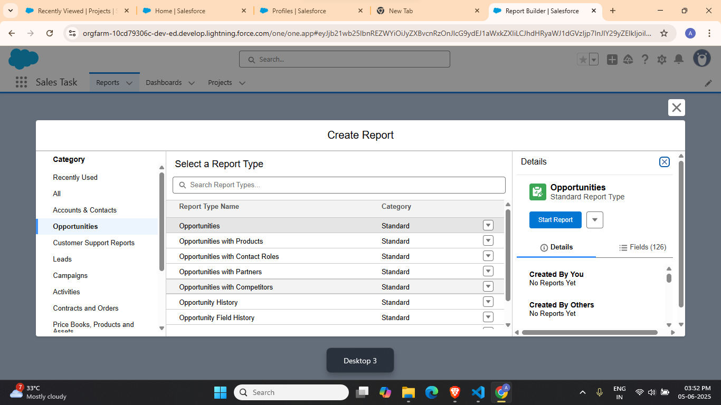

1. Click on Start Report and then Update Preview Automatically

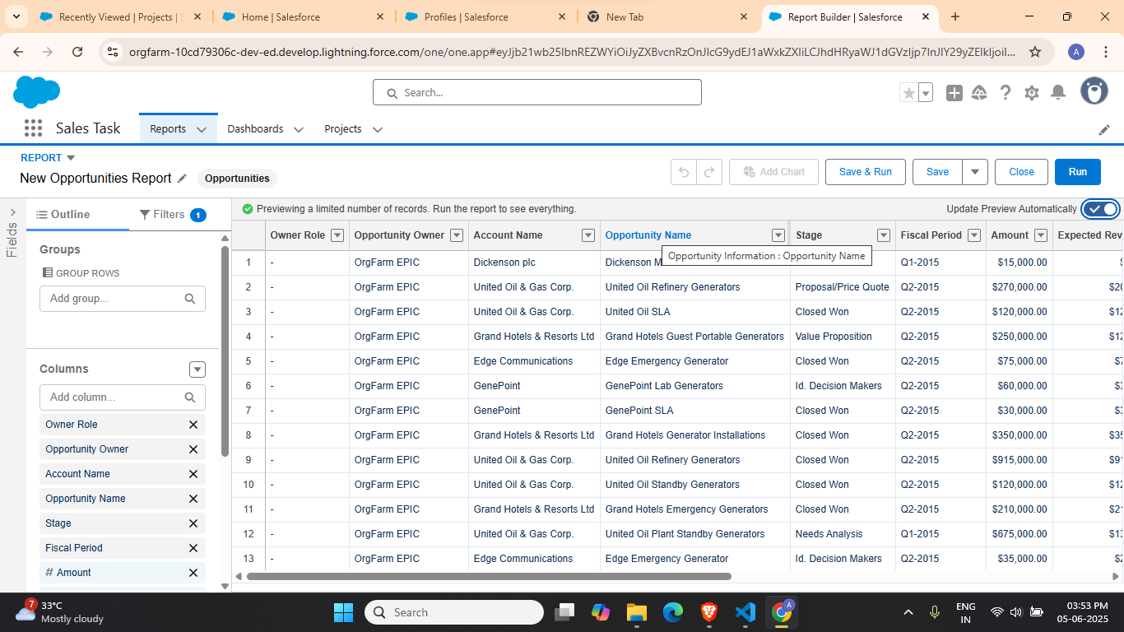

1. Delete columns which are not required

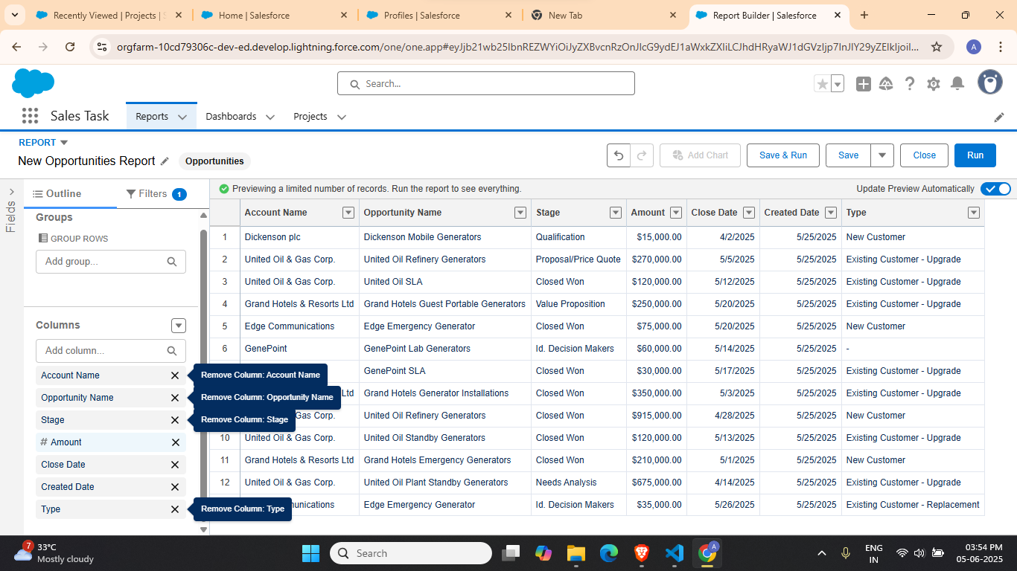

1. Group rows based on stage

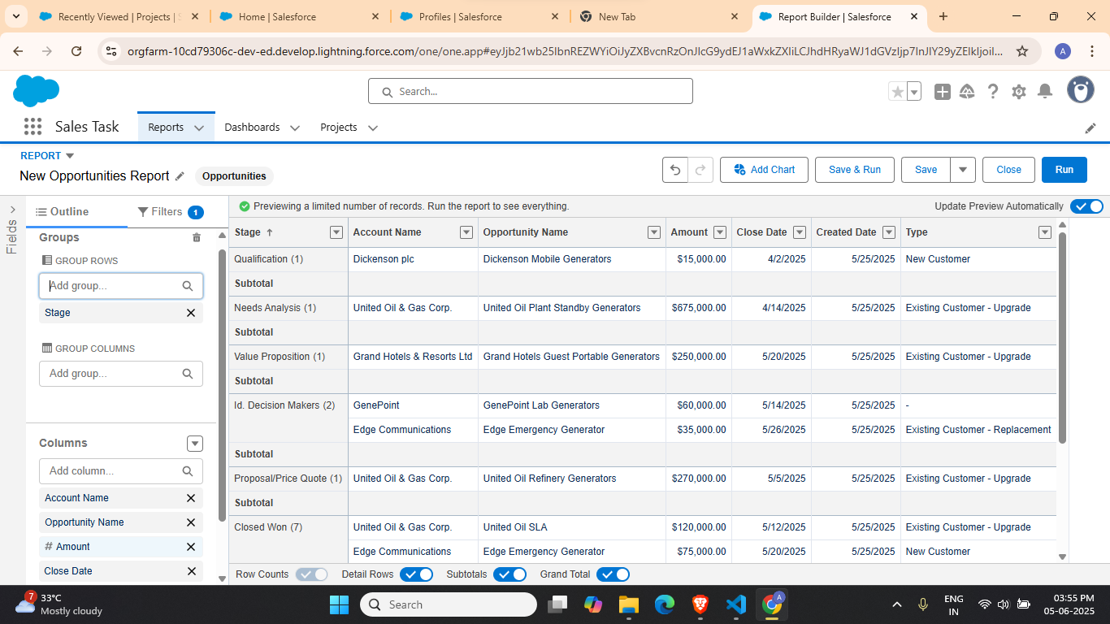

1. Save the Report

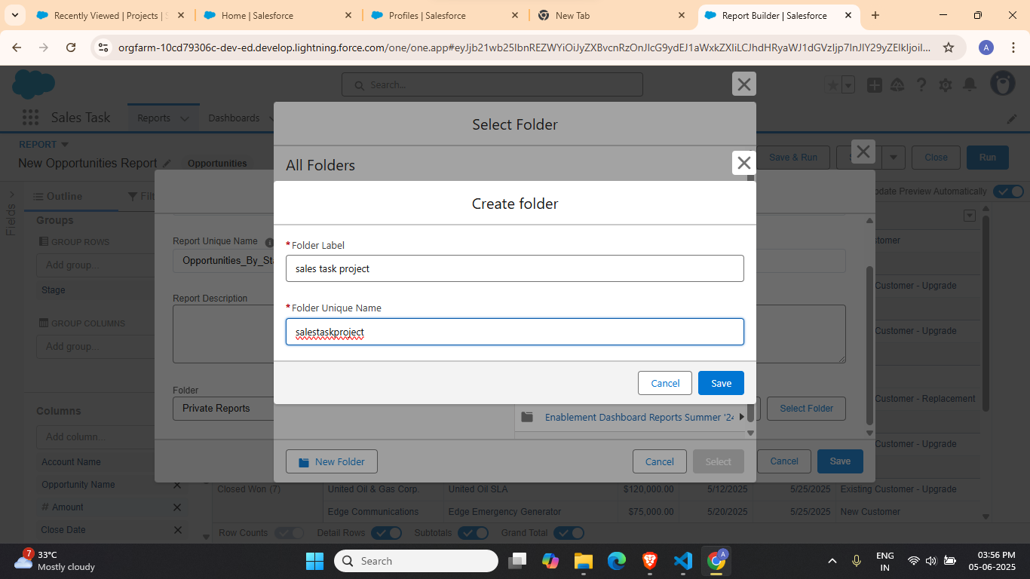

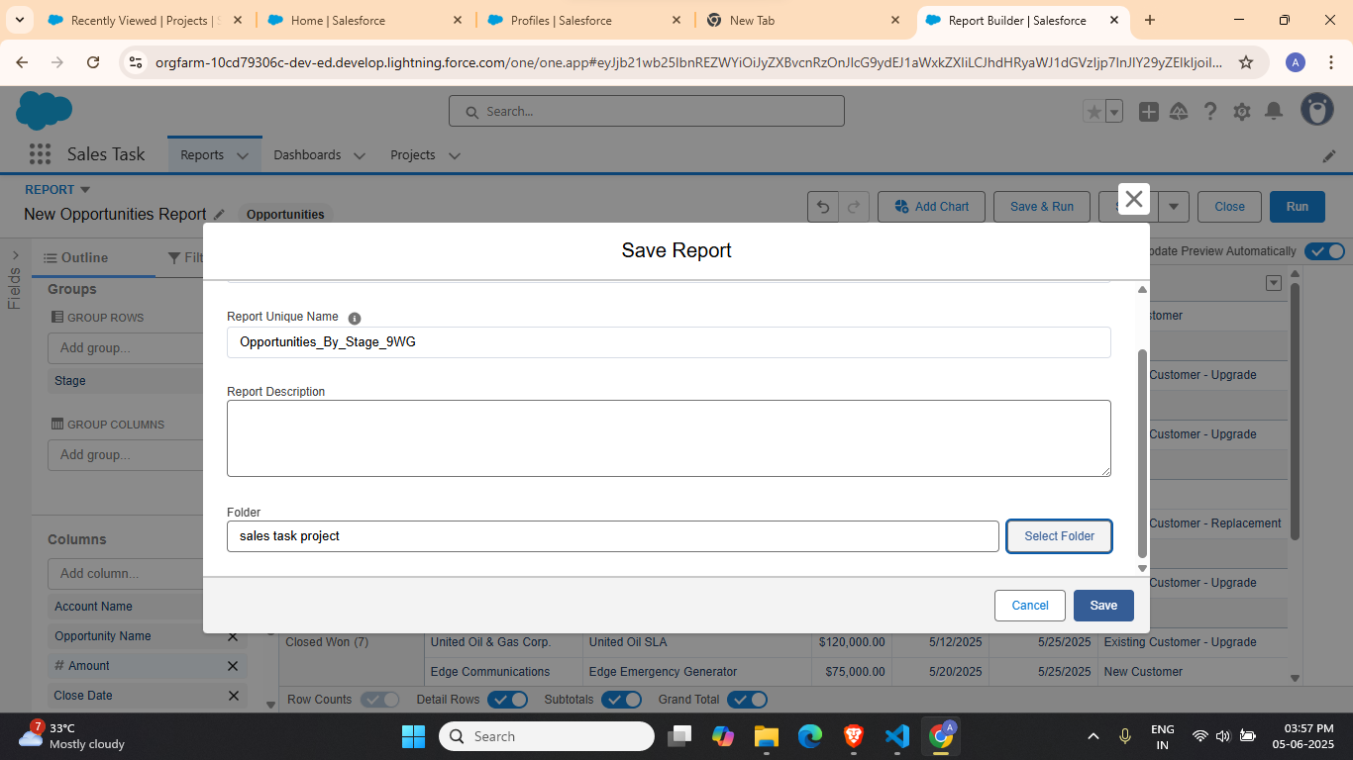

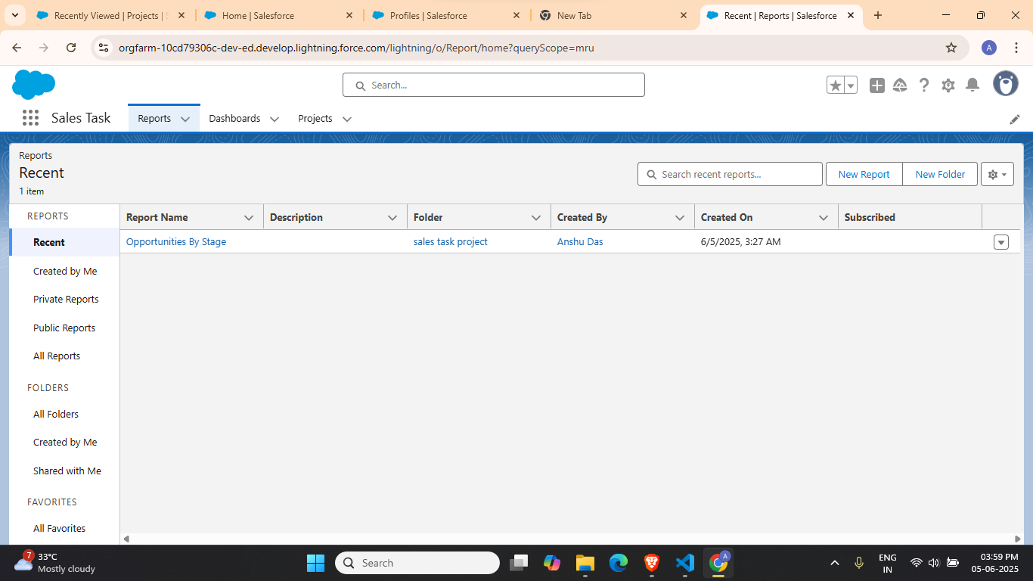

Report2 on Project by status and budget range

1. Click New Report and search for Projects

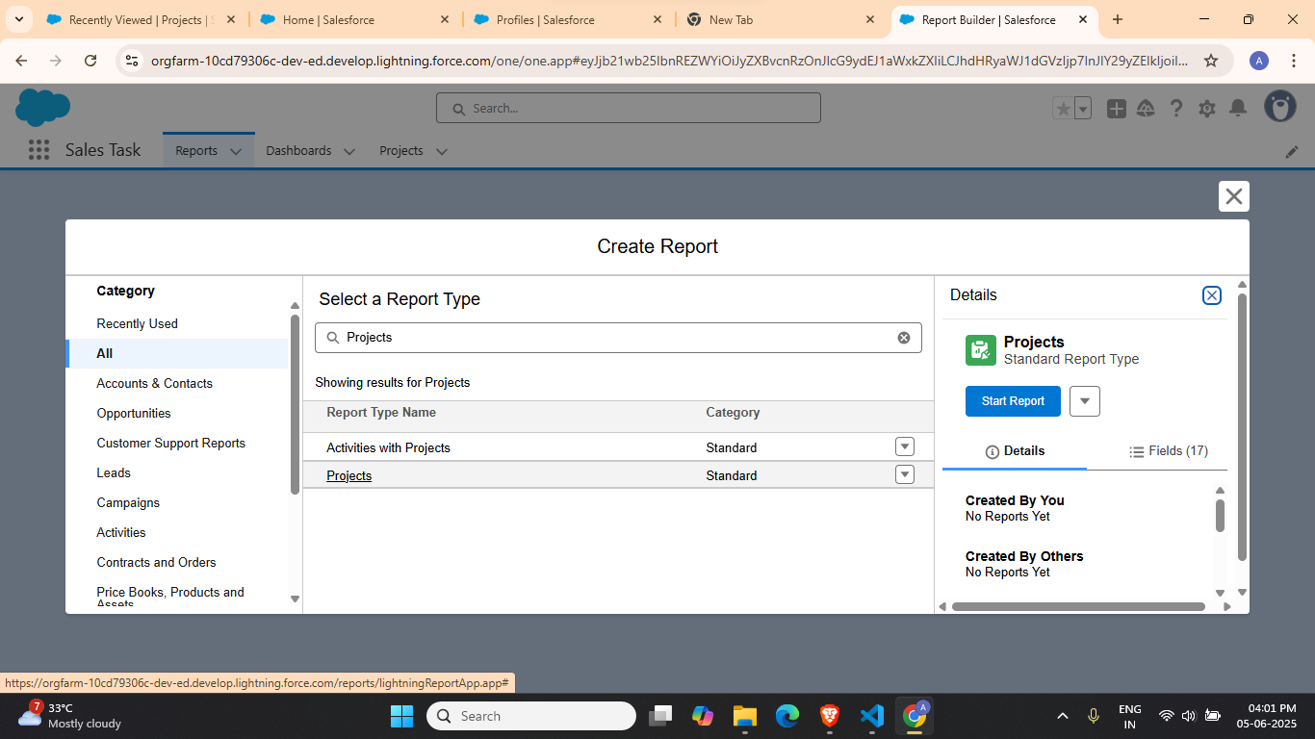

1. Click on Start Report and add required columns

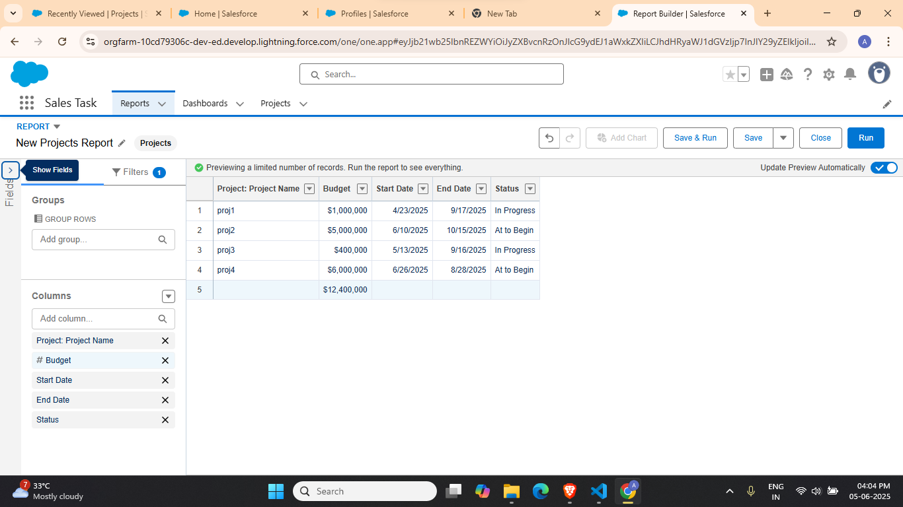

1. Group on status and budget

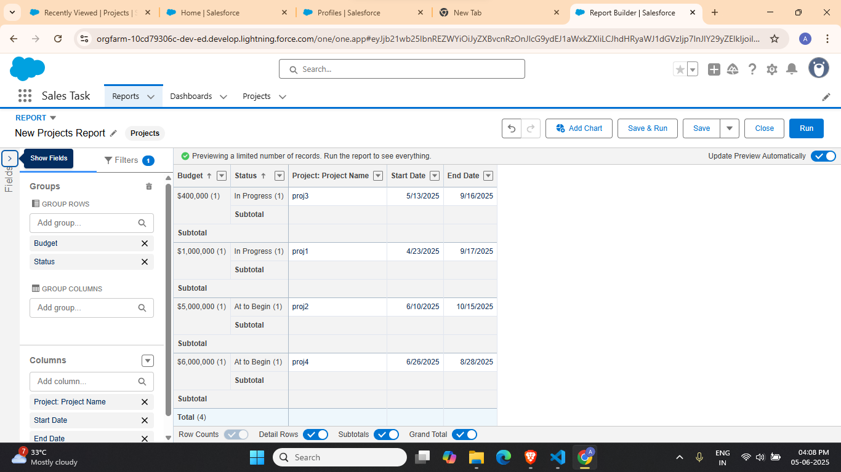

1. Save the report

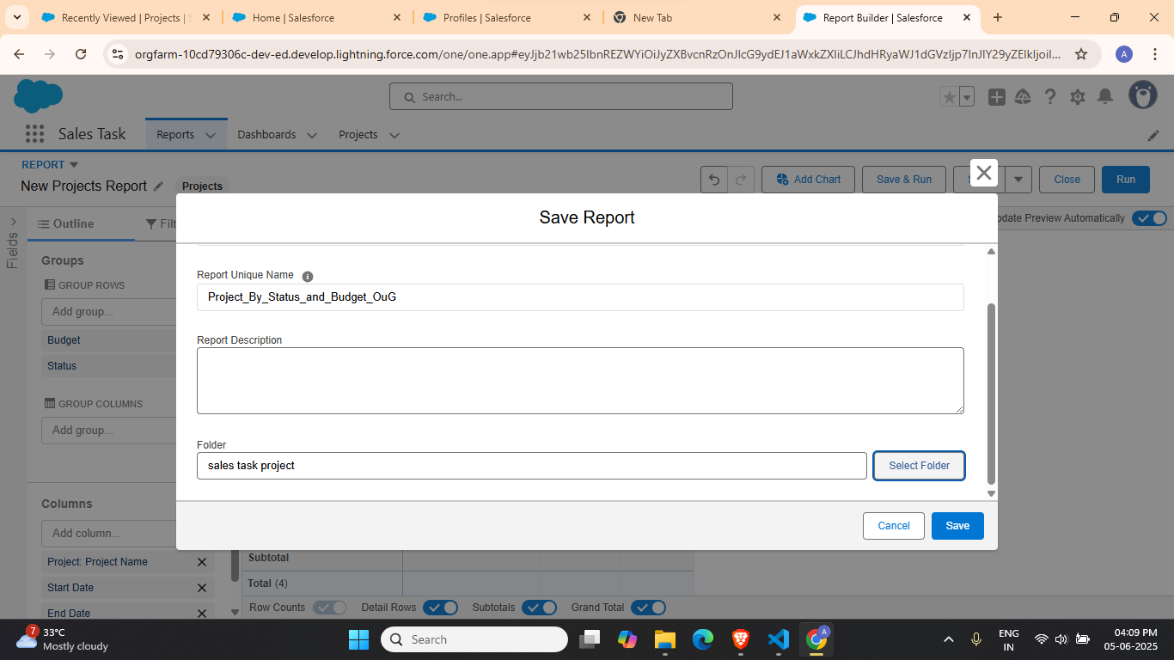

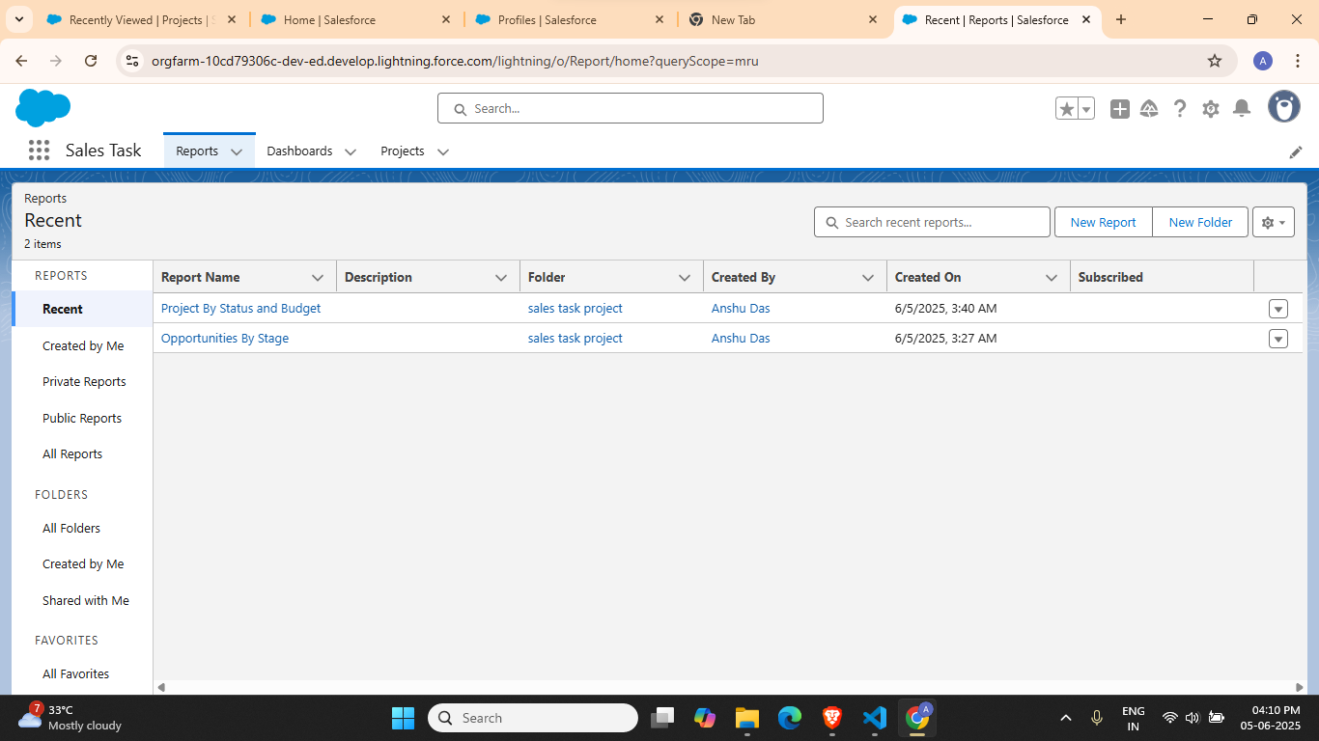

Task 3: Build a dashboard that includes these reports with the following components:

* Bar Chart
* Pie Chart
* Table View

1. Click on the Dashboards tab

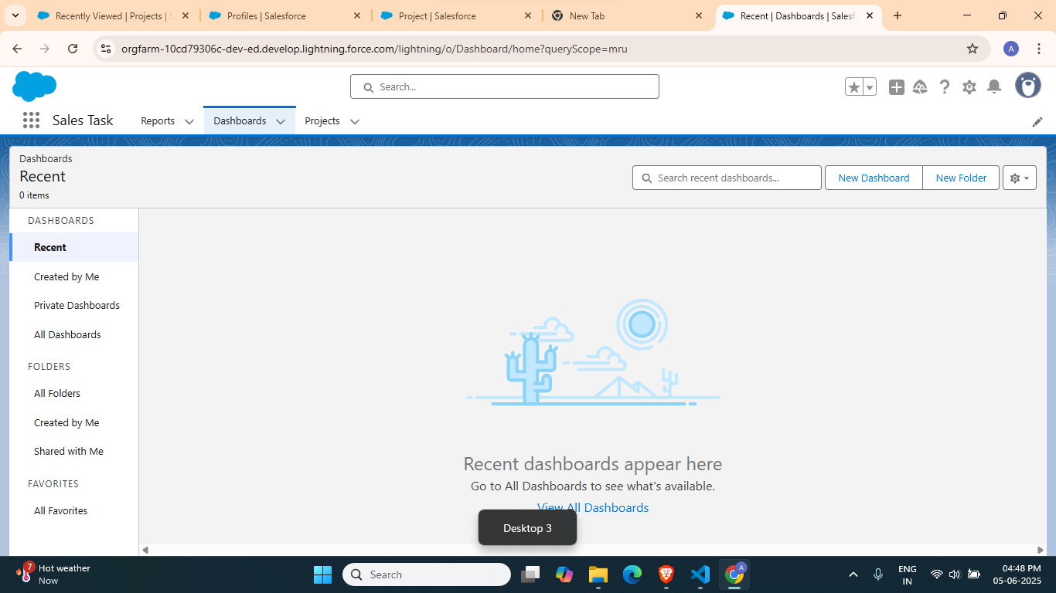

1. Click on New Dashboard and save in New folder

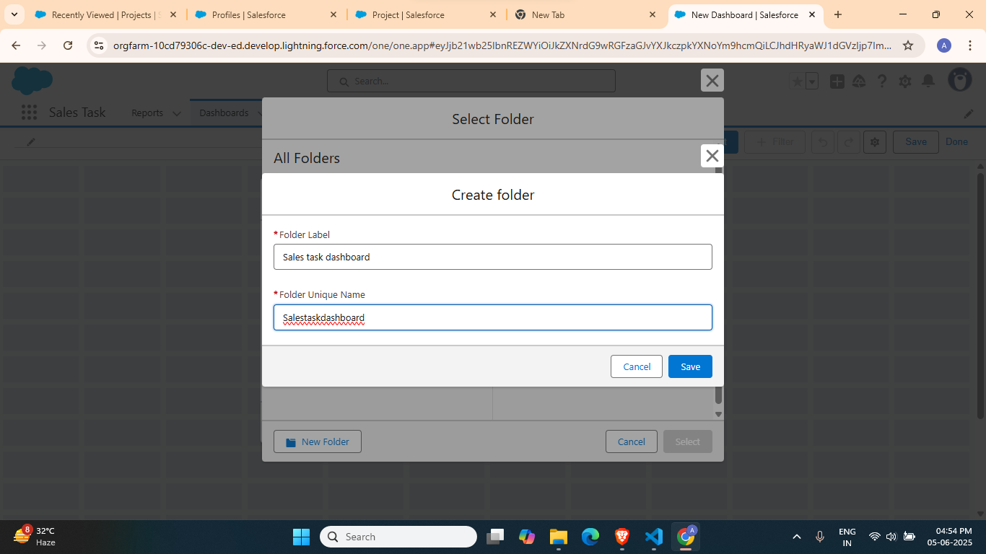

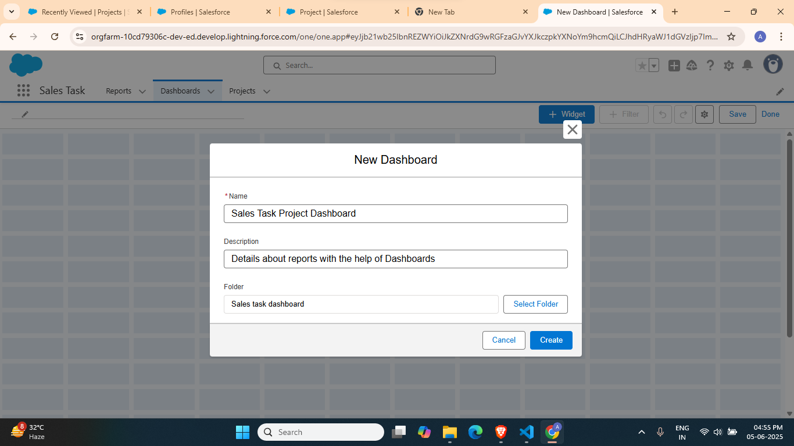

1. Click on Widget and then Chart or Table

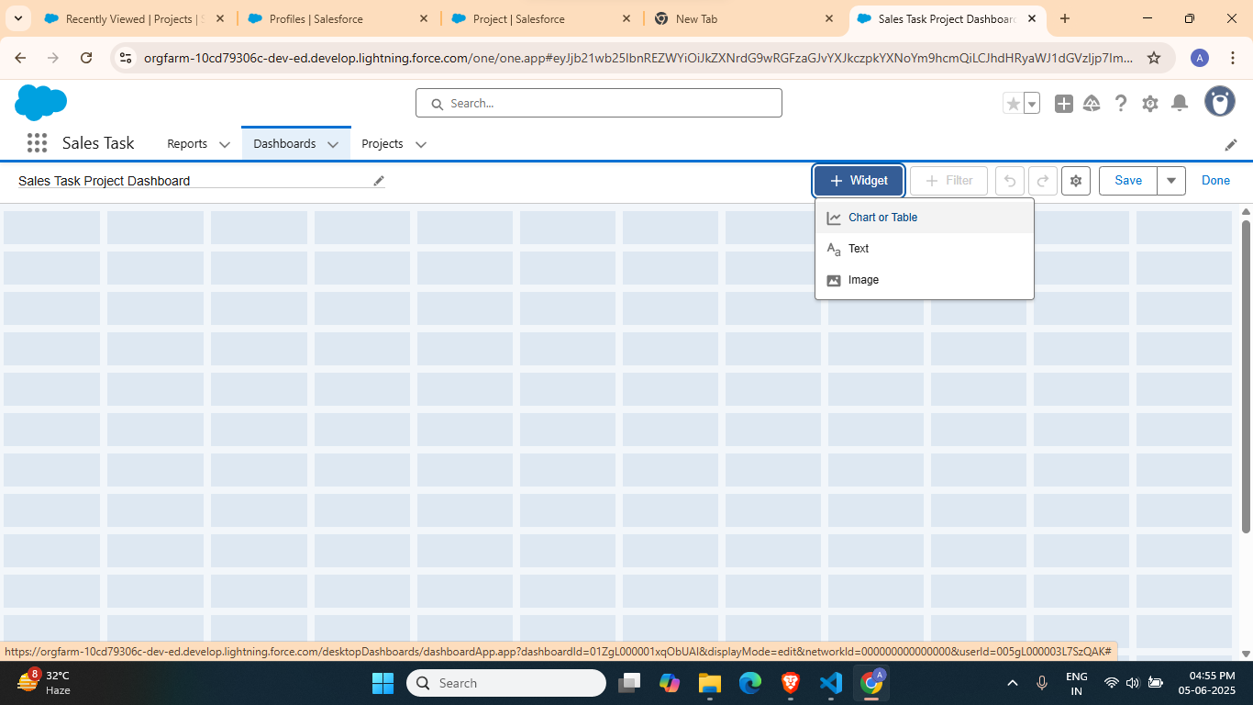

1. Select a Report

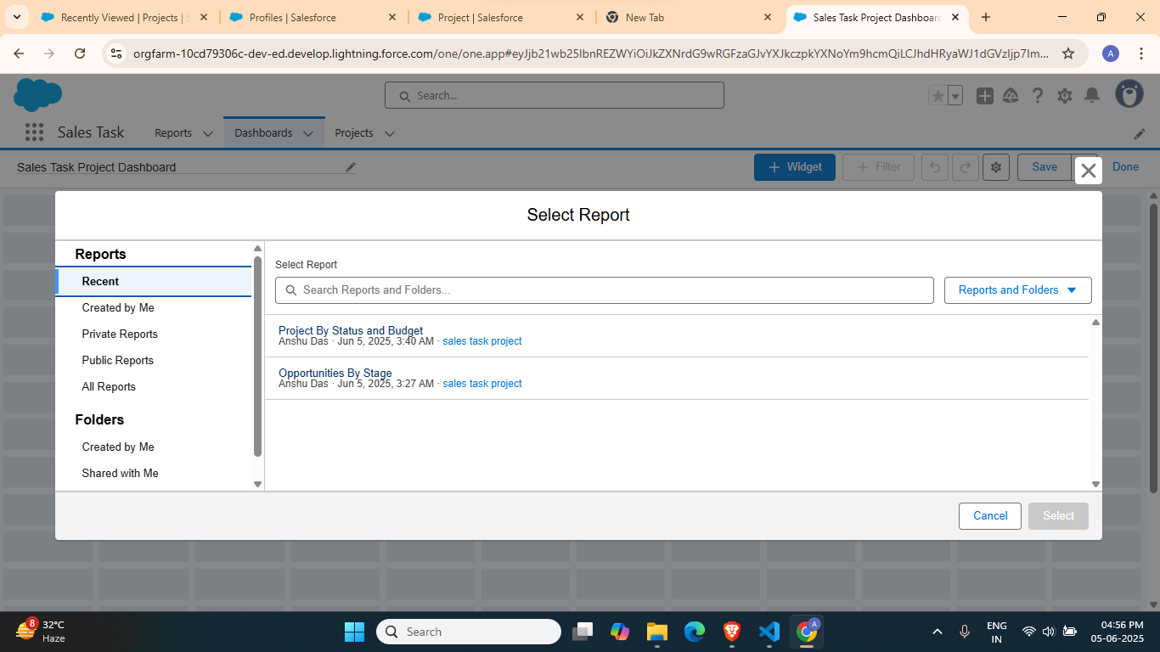

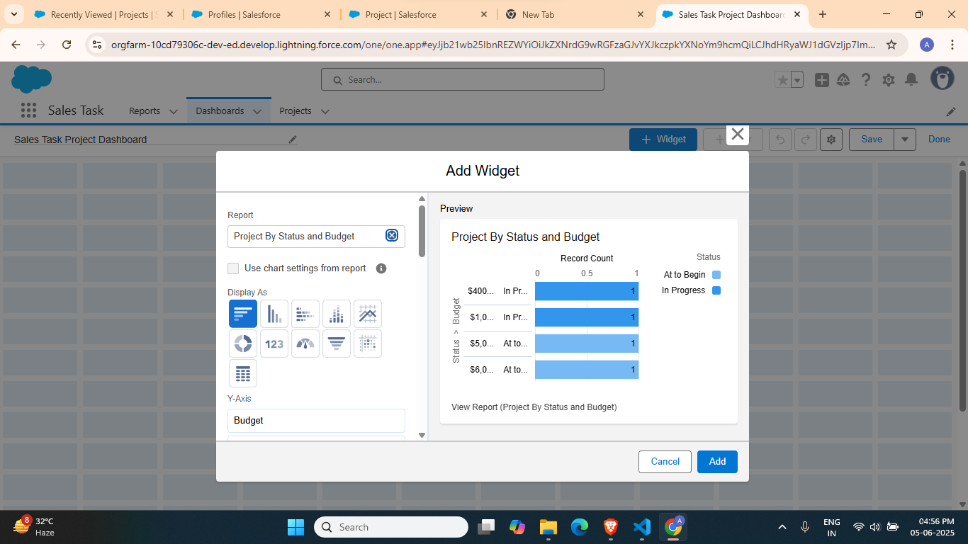

1. Bar chart

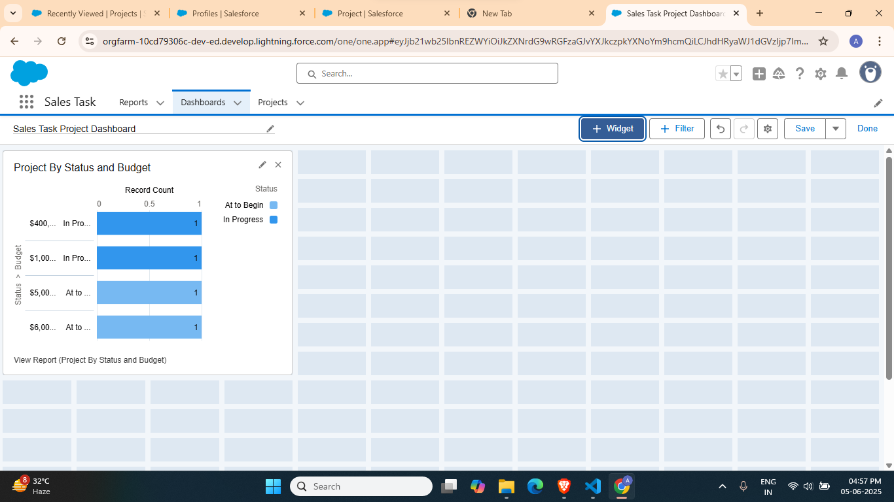

1. Pie Chart

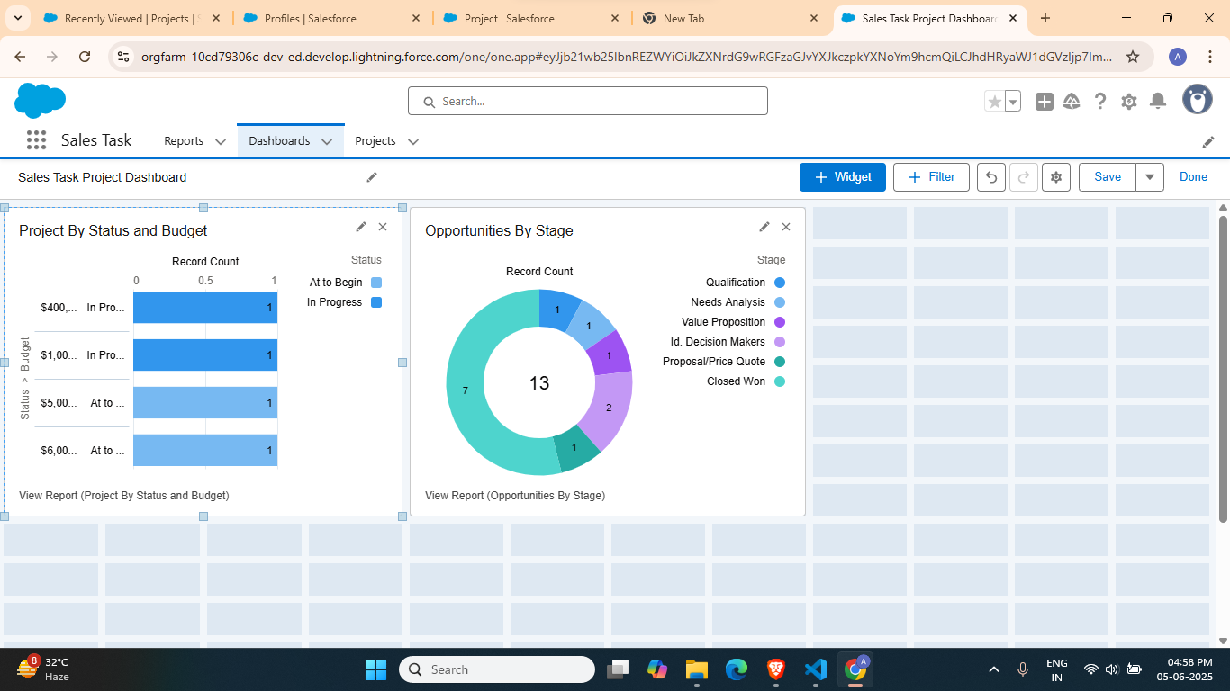

1. Table View

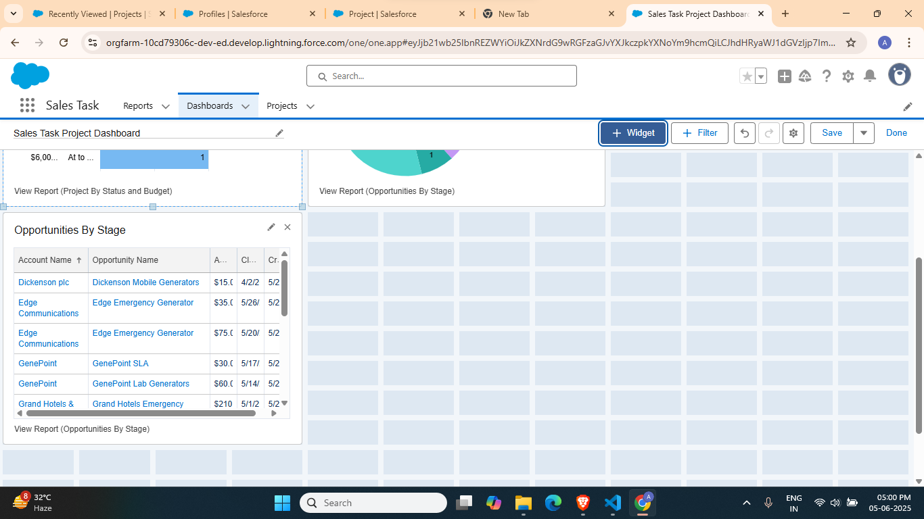

Task 4: Set up report scheduling and dashboard sharing with specific user roles.

1. Go to the Reports tab of Sales Task App and click on ‘All Folders’

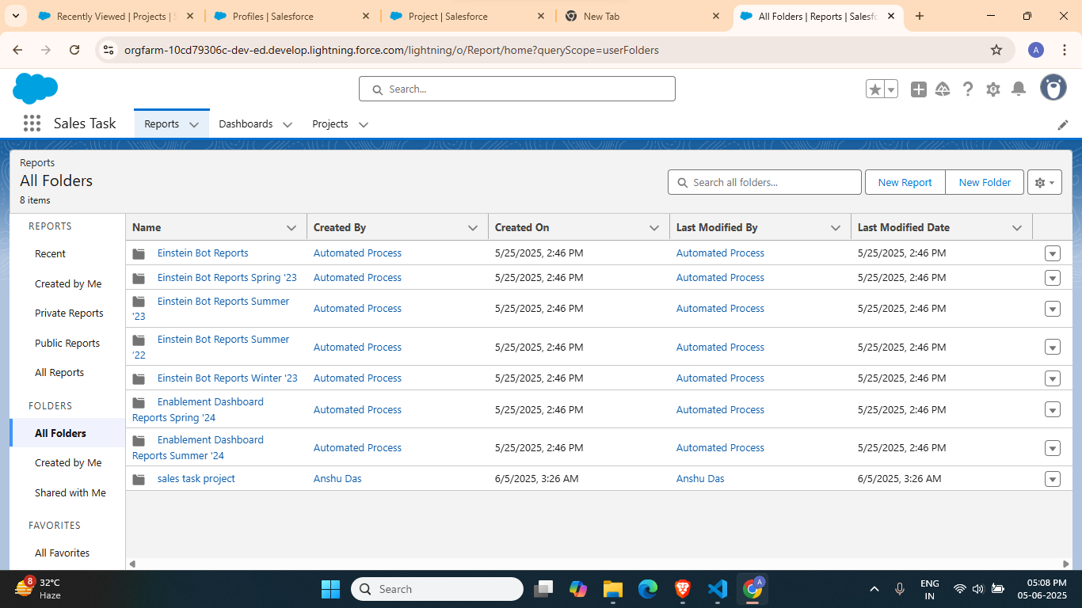

1. Click on the share option for Sales task project folder

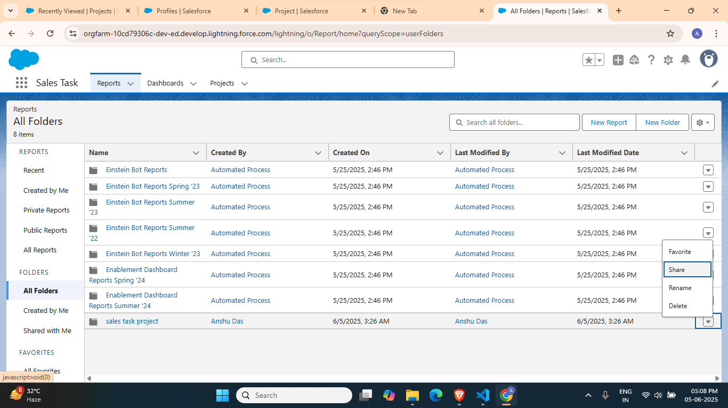

1. Give permissions and click on ‘Done’

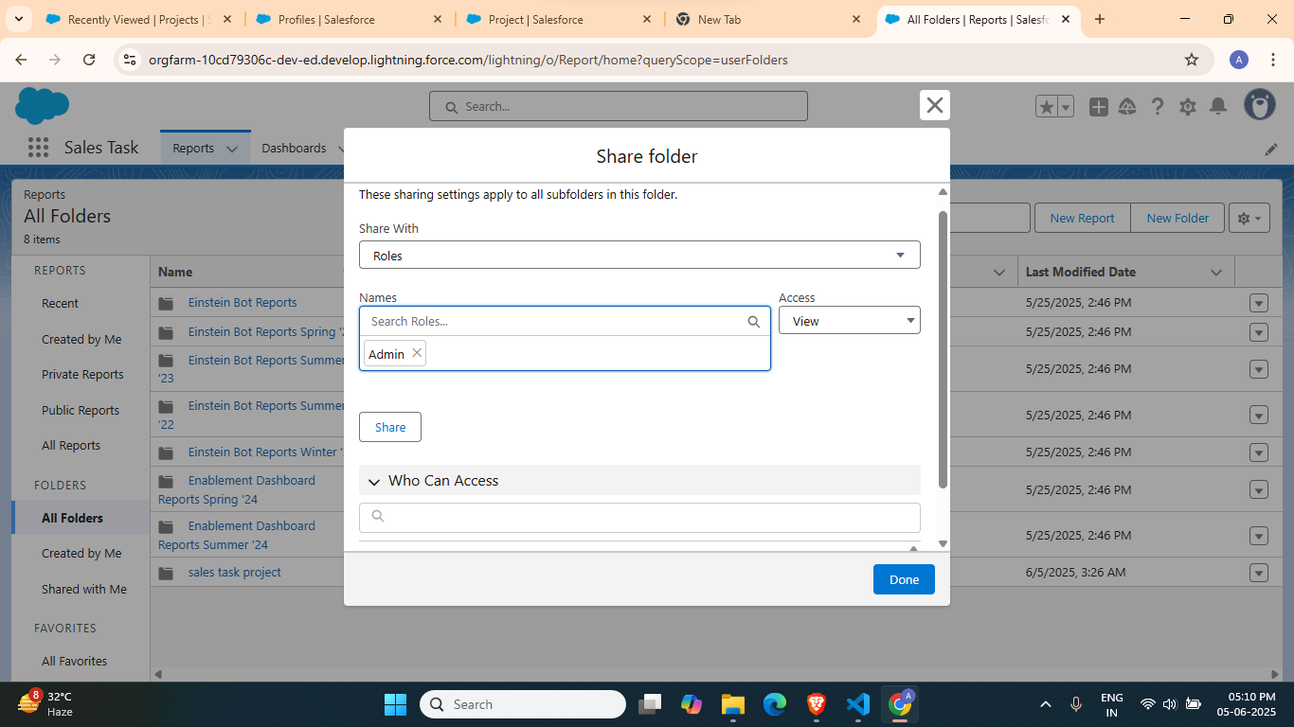

Task 5: Explain how analytics can improve decision making for sales or service teams.

Analytics enhances decision-making for sales and service teams by transforming raw data into actionable insights. With access to real-time metrics and historical trends, teams can better understand customer behaviour, forecast outcomes, and optimize their strategies. For sales teams, analytics helps in identifying high-potential leads, tracking performance, and increasing conversion rates. Service teams, on the other hand, can use analytics to monitor response times, resolve issues faster, and improve customer satisfaction. Overall, analytics leads to more informed, data-driven decisions that boost efficiency and results.

Key benefits of analytics for sales and service teams:

* **Improved forecasting**: Helps predict sales trends and service demands.
* **Lead prioritization**: Identifies which prospects are most likely to convert.
* **Performance tracking**: Monitors team and individual productivity.
* **Customer insights**: Enables personalized communication and support.
* **Proactive issue resolution**: Detects potential problems before they escalate.
* **Resource optimization**: Ensures efficient use of time and staff.

By leveraging analytics, organizations empower their sales and service teams to act strategically, deliver better customer experiences, and drive business growth.